**Assignment 24.1**

**Problem Statement:**

Explain with an example in brief.

● Hive Data Definitions

● Hive Data Manipulations

● HiveQL Manipulations

**Answer:**

* **Hive Data Definitions:**

It includes commands that define the different structures in a database.

HDL is a subset of Hive SQL statements that describe the data structure in Hive by creating, deleting, or altering schema objects such as databases, tables, views.

The commands are:

CREATE, DROP, TRUNCATE, DESCRIBE, AND ALTER.

Syntax:

CREATE TABLE HIVE_TABLE (abc INT, xyz STRING); // creating tables

DROP ‘TABLE NAME’; // deleting the table or database

TRUNCATE – used to delete the structure of the table.

ALTER - used to change the structure of the table.

* **Hive Data Manipulations:**

It includes commands used to modify the values in the table or to extract the data from the table.

The commands are:

LOAD, INSERT, UPDATE, DELETE

* + LOAD: load the data into a table.
  + Update: change the entries in the table.
* **HiveQL Manipulations:**

HiveQL Manipulations are of three types:

a) Select where

b) Select order by /sort by

c) Select group by

Select where: used to filter the dataset with the where clause and apply the conditions.

Select order by clause: used to arrange the dataset in the ascending or descending order by one field or multiple fields.

Select group by: used to form subsets of the database using different fields of the data.

**Create and load command:**

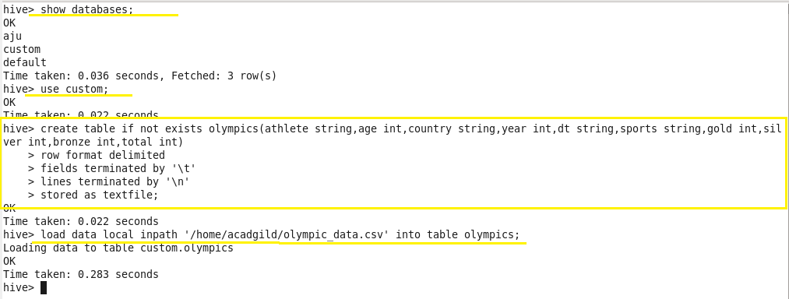

**Select command:**

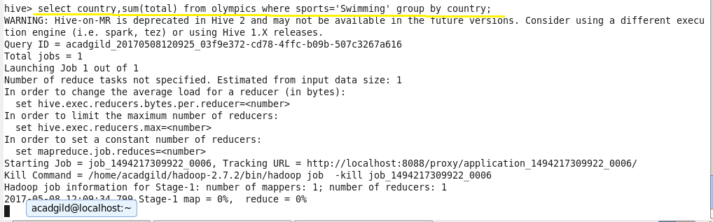

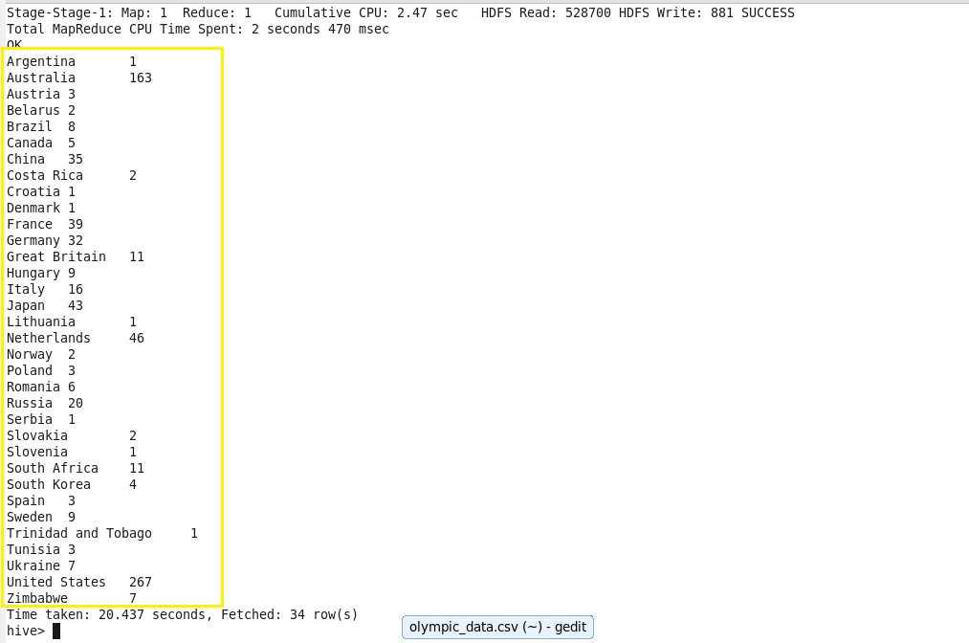

**Select where command & select group by command:**

